**Code profiling analysis**

**Antonio-Mihai Dima**

For code profiling analysis a 21 second debug performance profiler test was conducted.

The first metrics that were checked were the GPU and CPU ultilization. The GPU was very low. The CPU had a spike in % used memory at runtime, as all functions into init() (in the main script) were called. After that, the CPU usage dropped considerably.

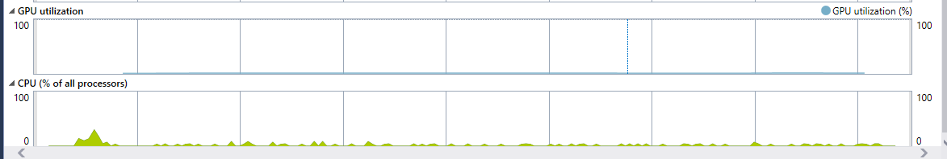

In terms is what scripts are the most extensive in the project, the gameloop draw() function used the most memory out of the self made scripts. Made sense because it compiled all the draw functions into one script.

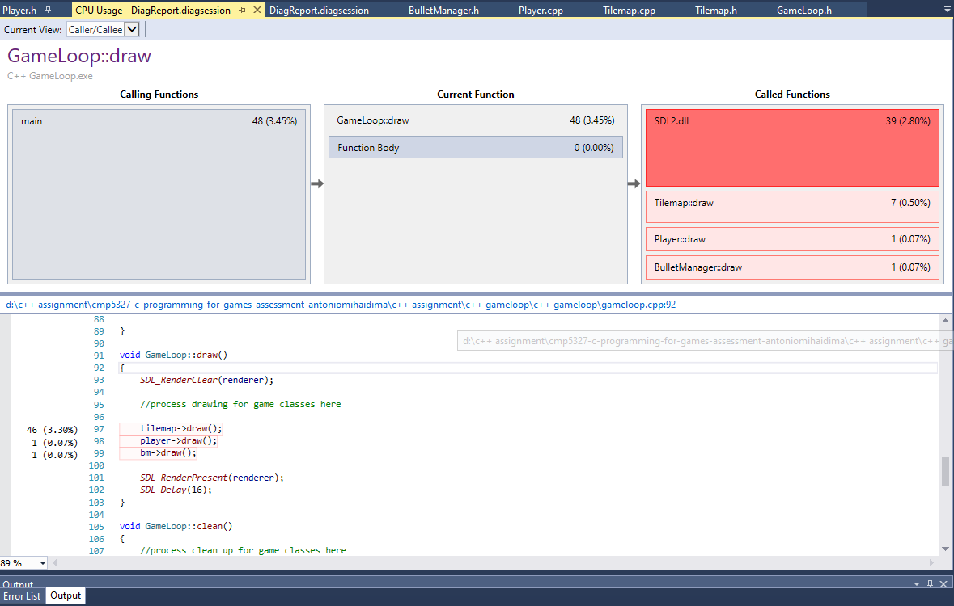

Here code analysis was made for the main loop.

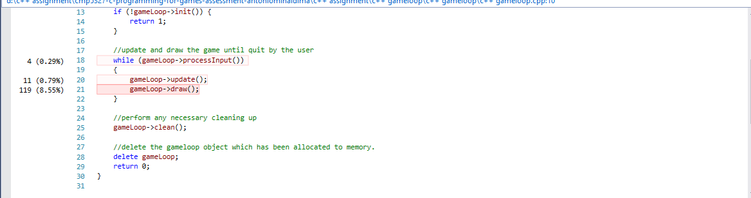

The longest script in this project was the Tilemap script, specifically the draw() function which rendered 1250 images at the same time to form the background map. The usage is still really low (0,50%).

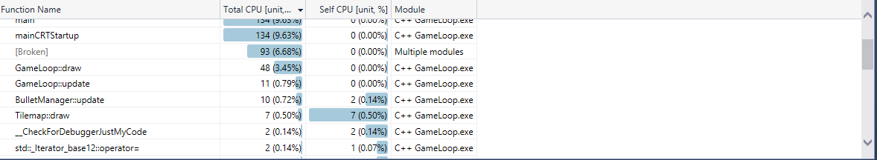

The game had between 30 and 60 FPS and a constant framerate of 17 ms.

